

**FACT SHEET: What is ‘Co-Active’ anyway?**

**The Impetus**

In this performance-rewarding environment, it’s easy to lose sight of the value of real connection, intimacy, self-awareness, listening deeply to and nurturing others – the very qualities that inform and inspire what we do, restore us and give our lives fulfilling meaning. Cultivating “being” virtues has been all but ignored – not to mention underestimated.

But times are changing as the world becomes more and more complex and yet smaller. The need for us to work together to lead effectively is urgent. Relationship intelligence is suddenly paramount to success. We at CTI consider this good news, though: We’ve been training tens of thousands for the past 20 years to balance the “being” and the “doing” and have seen firsthand how our Co-Active Model catapults individuals and organizations into both higher achievement *and* deeper connection and fulfillment. Transformational change is our business. We want a world that works for everyone where people know that who we are is as important as what we do.

**The Co-Active Model**

The Co-Active Model balances self-awareness, a keen agility with relationships, and courageous action to create an environment where individuals can be deeply fulfilled, connected to others and successful in what matters most.

The “Co” in Co-Active stands for relationship, connection, intimacy and collaboration. Thus, the “Co” in us is curious, listens deeply, hears nuance, holds space for others, intuits and nurtures.

The “Active” in Co-Active stands for power, direction, action and manifestation. So, the “Active” in us is courageous, has clarity and conviction, takes charge and achieves goals.

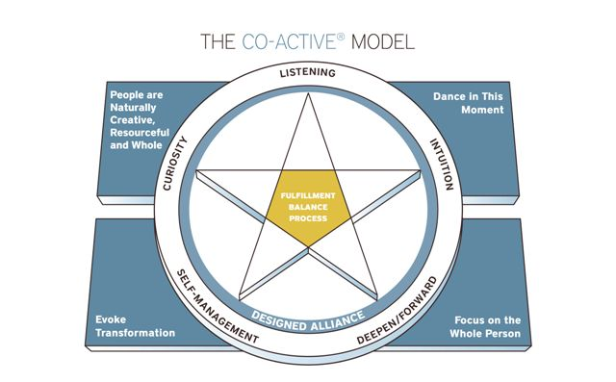

The magic happens in the dance between “Co” and “Active” — action that arises from presence, deep relationship and context…and presence that is channeled into dynamic action and contribution. Balancing and blending these energies allows us to move out of an “either/or” paradigm into a “yes/and” paradigm.

**Co-Active Training**

Through Co-Active training, CTI is creating a transformative change in the way people relate to and work with each other. The work inspires people to feel engaged in and passionate about their life and work, see the good, get curious, create interactions unlike any other, become visionary, feel more alive, connect deeply to others, give real meaning to their lives, think much bigger, become great leaders and make a difference.

The Co-Active Model spawned a philosophy, a methodology, a skill set and a communication form that is being applied in business, education, medicine, government, communities and families all around the world.

**MEDIA CONTACT:**

Amy Logan

CTI Director of PR

[amylogan@thecoaches.com](mailto:amylogan@thecoaches.com)

office (415) 419-5557

cell (949) 637-9620